Chapters 8 and 9
Lipids, Membranes and Membrane Transport

8.1: Recognize the physical characteristics of lipids.

- Explain how fatty acids are esterified to make larger structures.
- Describe the structures of amphipathic lipids.
- List some functions of lipids.

fatty acid structure

fatty acid nomenclature: systematic vs. shorthand naming system

triacylglycerols

glycerophospholipids: choline, ethanolamine, glycerol, and serine

phospholipases: A₁, A₂, C, and D

sphingolipids: sphingomyelins, cerebrosides, and gangliosides

archaeal lipids

isoprene derivatives: cholesterol and ubiquinone

waxes

arachidonate derivatives

plant lipids: geraniol, limonene, and capsaicin

lipid vitamins: A, D, E, and K

Vitamin A

Vitamin D

Vitamin E

Vitamin K

8.2: Describe the physical properties of the lipid bilayer.

- List the ways that membrane lipids can move.
- Relate lipid composition to bilayer fluidity.
- Compare transverse and lateral lipid diffusion.

lipid bilayer formation

thermodynamic forces

variations in lipid behavior

bilayer fluidity

T_{M} and membrane fluidity

cholesterol in eukaryotes

lipid rafts

bilayer diffusion – lateral vs. transverse

8.4: Summarize the features of the fluid mosaic model.

composite structure of lipids and (glyco)proteins

leaflet differentiation

mobility limitations

glycoprotein diversity

8.3: Explain how proteins associate with membranes.

- Distinguish integral, peripheral, and lipid-linked membrane proteins.
- Describe how an alpha helix or beta barrel spans the membrane.

membrane-associated proteins: integral, peripheral, and lipid-linked

lipid-linked proteins: myristoylation, palmitoylation, prenylation

“glycosylphosphatidyinositol-ation”

alpha-helical transmembrane proteins

beta-barrel transmembrane proteins

9.2 Passive Transport

Describe the operation of passive transport systems.
- Compare the structures of porins, channels, and transporters.
- Explain the mechanisms of solute selectivity in the different types of transporters.
- Describe the role of conformational changes in the GLUT proteins.
- Compare transport proteins to enzymes.

porins

ion channels

gated ion channels

mechanosensitive channels

aquaporins

glucose transporter (GLUT)

transporters vs. enzymes

9.3: Active Transport

Describe the operation of active transport systems.
- Distinguish primary and secondary active transport.
- Describe the reaction sequence of the Na,K-ATPase.

primary active transport: Na,K-ATPase

secondary active transport: Na-Glc transporter

9.1: Thermodynamics of Membrane Transport

Explain how ion movements affect membrane potential.
- Calculate the membrane potential from ion concentrations. (calc 9.1)
- Describe the ion movements of an action potential.
- Analyze the thermodynamics of ion movement across membranes. (calc 9.2, 9.3)

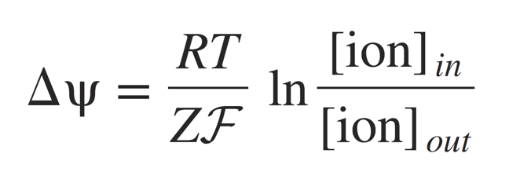

R = 8.3145 J/K*mol
F = 96,485 J/V*mol
Z = net charge per ion

ΔG = RT ln [X]_{in}/[X]_{out}

ΔG = RT ln [X]_{in}/[X]_{out} + ZFΔΨ

intra/extracellular concentrations of Na+/K+

ion movements during action potential

resting potential:

depolarization:

repolarization:

propagation of signal:

directionality:

9.4: Membrane Fusion

Describe the process of membrane fusion.
- Summarize the events that occur at a nerve-muscle synapse.
- Describe the role of SNARES and membrane curvature in vesicle formation.
- Compare exocytosis and endocytosis.

exocytosis: neurotransmitter release

membrane fusion/lipid remodeling

SNARE complexes

endocytosis

exosomes

