Enzyme Kinetics and Inhibition

7.1: Explain why an enzyme’s activity varies with the substrate concentration.

- Describe how an enzyme’s activity is measured.

measurement of reaction velocity

velocity vs. [enzyme]

velocity vs. [substrate]

- Depict enzyme saturation in graphical form.

7.2: Use the Michaelis-Menten equation to describe enzyme behavior.

- Distinguish first order and second order reactions. (calc. 7.1)

first order velocity

second order velocity

- Describe the changes in the concentrations of S, P, E_{T}, and ES during the course of an enzyme-catalyzed reaction. (calc. 7.2)

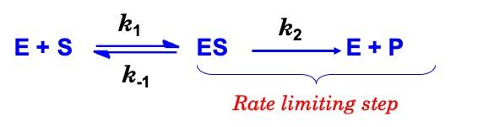

steady state equilibrium

d[ES]/dt = 0

dissociation/association

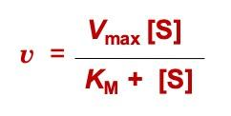

- Define K_{M} and k_{cat}.

expression of rate constants

estimation of affinity

catalytic constant

catalytic efficiency

- Derive the values of K_{M} and V_{max} from graphical data. (calc. 7.3)

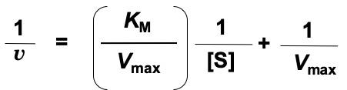

multisubstrate reactions

multistep reactions

nonhyperbolic reactions

7.3: Distinguish the effects of different types of enzyme inhibitors.

- Compare the action of reversible and irreversible inhibitors.

suicide inhibitors

reversible inhibition

- Describe the effects of competitive, noncompetitive, mixed, and uncompetitive inhibitors on a reaction’s K_{M} and V_{max}.

competitive inhibition

noncompetitive inhibition

mixed inhibition

uncompetitive inhibition

LB inhibitor plots

- Express inhibitor strength in terms of a K_{I} value. (calc. 7.4)

⍺ = degree of inhibition
K_{I} = inhibition constant
⍺ = 1 + [I]/ K_{I}

transition state analogs

allosteric enzymes

regulation of enzyme activity

