Regulation of Mammalian Fuel Metabolism

19.1: Integration of Fuel Metabolism

- Summarize the metabolic functions of liver, kidney, muscle, and adipose tissue.
  - Identify the major sources of fuel in each organ.
  - Describe the mobilization of stored fuel in each organ.
  - Trace the movement of metabolites between organs.

organ/cellular compartmentalization

- Compartmentalization = regulation
- Organ specialization = compartmentalization
- Organ functions respond to fed/fasted/active state
- Liver: gluconeogenesis, ketogenesis, urea production
- Adipose: fat storage

liver

- Fed: glucose/fat stored; TAGs synthesized from glucose and amino acids exported
- Fasted: glucose mobilized and released to circulation; TAGs converted to Acetyl-CoA for ketogenesis; amino acids converted to glucose or Acetyl-CoA
- Lactate/alanine converted to glucose, nitrogen disposal via urea synthesis

muscle

- Fed: glucose stored as glycogen
- Active: glycogen catabolized for ATP production; f.a.s and ketones burned as well (CAC); cardiac muscle is constantly active and burns f.a.s as primary fuel
- Sustained activity: pyruvate converted to lactate and alanine, exported to liver
- Starvation: proteins hydrolyzed to amino acids for gluconeogenesis

adipose tissue

- Fed: glucose converted to glycerol + f.a.s = TAGs for storage
- Fasted: TAGs released for f.a. oxidation

kidney

- Primarily waste eliminating organ
- Minor role: converts a-ketoglutarate to glucose via gluconeogenesis

Cori cycle

- Liver releases glucose to tissues via circulatory system
- Amino groups travel to liver and kidney for disposal
- Lactate produced during sustained exercise is exported to liver and converted to glucose
- Transport back to muscle feeds activity post glycogen depletion
- Recycles waste from NAD+ regeneration
- Energetic transfer from liver (from fatty acid oxidation) to muscles = energy cycle

glucose-alanine cycle

- Muscle breakdown during sustained exercise generates intermediates to feed CAC (a-KG)
- Alanine produced via transamination is exported to liver
- Amino group removed via deamination, then used for urea synthesis
- pyruvate converted to glucose via gluconeogenesis
- Transport back to muscle feeds activity post glycogen depletion
- Energetic transfer from liver to muscles
- Disposes of nitrogenous waste; transported from muscles to liver (as alanine)

19.2: Hormonal Control of Fuel Metabolism

- Describe the effects of insulin, glucagon, and epinephrine on fuel metabolism.
  - Summarize the effects of insulin on muscle, adipose tissue, and liver.
  - Recount how epinephrine and glucagon signaling lead to fuel mobilization.
  - Describe the role of AMP-dependent protein kinase.

- Metabolic processes are continually adjusted to accommodate cellular needs
- Fuels are continually stored, mobilized, and replenished
- Brain requires continual supply of glucose
- Cardiac muscle preferentially to burns fat
- Activity is hormonally controlled: insulin, glucagon, epinephrine and norepinephrine
- Also regulated are appetite regulation, fuel allocation, and body weight

insulin signaling

- Stimulates glucose uptake; inhibits glycogen breakdown
- Post-prandial rise in blood glucose stimulates insulin release from b-islet cells
- Glucose metabolism generates insulin-releasing signal
- Glucokinase ~ hexokinase (liver and pancreatic); high K_{M} decreases saturation, increases sensitivity to [glucose]
- Kinetics of glucokinase indicate cooperativity within the monomeric enzyme
- Substrate-induced conformational change could increase affinity for subsequent substrate binding
- Cooperativity enhances glucose binding when [glucose] rises
- Insulin binding to receptor initiates RTK signal transduction; IRS-1 and IRS-2 are downstream targets

insulin action (muscle/adipose/liver)

- Hormone response depends on cell-specific receptors
- Generally, insulin = abundance (fuel storage)
- Glucose transport is increased by translocation of transporters (GLUT4) to membrane; passive transport
- Transporters returned once insulin signal is removed
- Insulin binding to adipose receptors causes f.a. uptake via activation of extracellular lipoprotein lipase
- Alters activity of glycogen metabolism

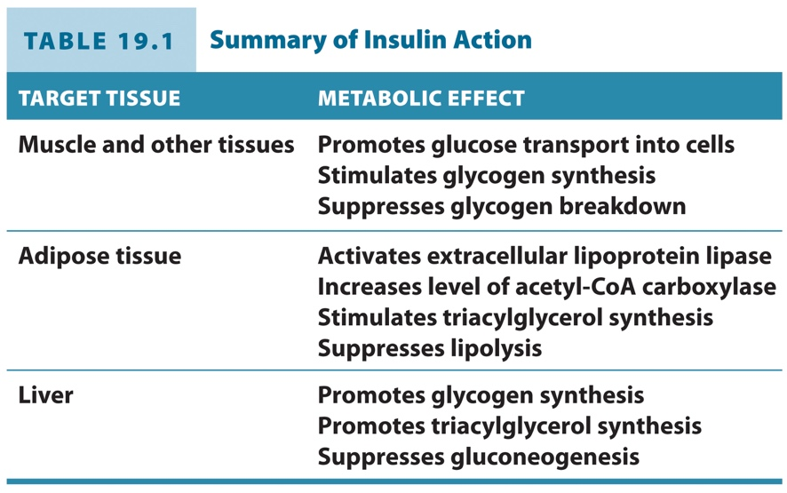

glycogen synthase/glycogen phosphorylase

- Glycogen synthase activated by G-6-P
- Glycogen phosphorylase activated by AMP/ inhibited by ATP
- Primarily regulated by phosphorylation
- phosphatases activate synthase
- Kinases activate phosphorylase
- Reciprocal regulation by single kinase/phosphatase

glucagon/epinephrine signaling: GPCRs

- Post-dietary uptake, cells rely upon glucose from glycogenolysis
- Pancreatic a-cells release glucagon at low [glucose]
- Binding of glucagon and catecholamines triggers GPCR cascade; + PKA
- Glucagon stimulates glucose release from stored glycogen as well as lipolysis in adipose tissue (muscle responds to catecholamines)
- +PKA activates phosphorylase kinase, promoting glycogenolysis via glycogen phosphorylase; phosphorylase kinase activity increased by Ca2+ from PI signaling = pathways converge
- +PKA relocates and activates hormone-sensitive lipase, mobilizing stored TAGs.

hormonal regulation of fuel metabolism

- Leptin: signals satiety; suppresses appetite via hypothalamus; levels proportional to adipose tissue
- Adiponectin: activates AMPK to increase catabolism of fuels and insulin sensitivity
- Resistin: blocks insulin activity; levels rise with obesity

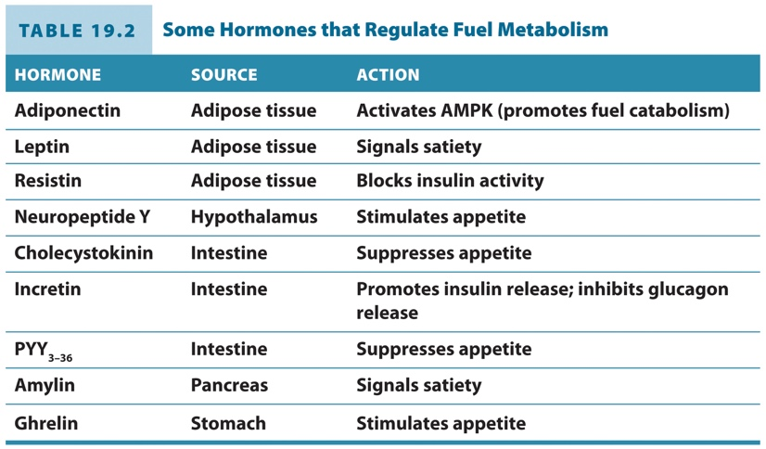

AMP-dependent protein kinase

- Cellular fuel sensor
- Regulated by AMP, ADP, ATP
- Ser/Thr kinase with regulatory and catalytic subunits
- Activated by phosphorylation at Thr residue
- ADP binding to regulatory subunit prevents dephosphorylation, maintaining kinase activity
- ATP inhibits AMPK, competes with AMP and ADP for binding to regulatory subunit
- AMPK regulates ATP consumption and production, i.e., PFK-2 activation in muscle; acetyl-CoA carboxylase inactivation (- f.a. synthesis, + oxidation)
- Promotes mitochondrial production

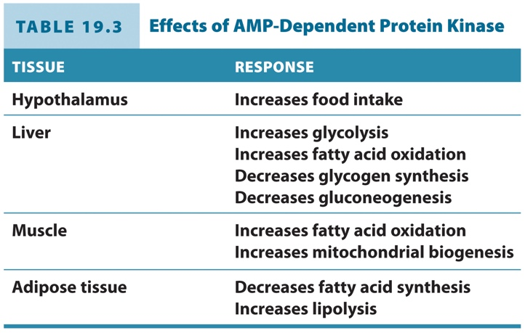

19.3: Disorders of Fuel Metabolism

- Compare the metabolic changes that occur in starvation, obesity, and diabetes
  - Describe how fuel use changes during starvation.
  - Compare brown and white fat and their contributions to obesity.
  - Describe the causes and symptoms of type 1 and type 2 diabetes.

sources of metabolic fuels

- Metabolic switch to burning fat shuts down insulin secretion, making more glucose available for brain tissue
- Liver and kidneys increase gluconeogenesis from proteins and fats
- Liver begins ketogenesis to prevent muscle degradation

dysregulation of fuel metabolism

- Physiological costs: lungs, heart, mechanical stress, increased risk of cardiovascular disease, diabetes, cancer
- Complex disorder of regulation of fuel metabolism
- Body weight set-point, leptin involved
- Leptin resistance leads to weight gain and higher set-point

adipose tissue: brown vs. white

- Brown: specialized for thermogenesis; high mitochondrial content; resembles muscle
- Responds to norepinephrine to activate lipase via PKA; liberates f.a.s from TAGs
- Expresses UCP in mitochondria

diabetes

- Type I = autoimmune, juvenile-onset; Tx with insulin and blood glucose monitoring
- Type II = insulin resistant, adult-onset
- Insulin insensitivity causes hyperglycemia and increased gluconeogenesis
- Increased glycosylation of proteins can cause tissue damage
- Conversion of glucose to sorbitol causes accumulation and disruption of osmotic balance; renal stress, protein precipitation leads to cataracts; neuropathies and circulatory problems from tissue damage; renal failure, heart attack, stroke, amputation
- Ketogenesis results in overproduction of ketone bodies, resulting in diabetic ketoacidosis

metabolic syndrome

- Related set of symptoms correlated with development of diabetes
- Obesity, insulin resistance, atherosclerosis, hypertension, increased cancer incidence
- High proportion of visceral fat leads to altered hormone profile (decreased leptin and adiponectin, increased resistin)
- TNFa promotes inflammation, insulin insensitivity
- Fat toxicity, impairment of GLUT4 translocation, increase in liver gluconeogenesis, b cell exhaustion from overstimulation

19.4: Clinical Connection: Cancer Metabolism

- Relate metabolic changes to the rapid growth of cancer cells

metabolic changes in cancer metabolism

- High rate of glycolysis, independent of O₂ levels
- Warburg effect: aerobic glycolysis
- Large consumption of glucose and disposal of waste as lactate
- Conversion of glucose to anabolic precursors promote cell division
- Diversion of intermediates to nucleotide and protein synthesis
- Glutamate dehydrogenase (amino group transfer) is regulatory point for cancer cells; inhibited when f.a. synthesis is high
- GDH activated by ADP; inhibited by GTP

